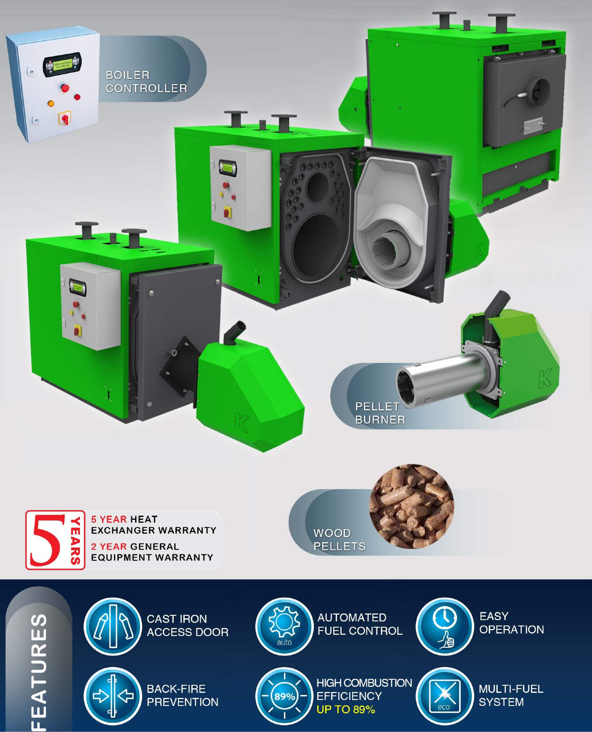

RENEWABLE ENERGY CONSULTANTS, LLC

Distributor of
SIM / EKO-TECH PELLET BOILERS

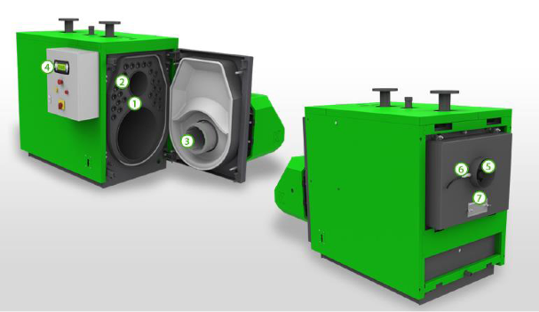
1. 3-Pass boiler - constructed from high quality boiler plate

2. Boiler tubes

3. Platinium Eko – self-cleaning pellet burner with automated ignition

4. Control Panel – industrial quality with full modulation Fuzzy Logic controller

5. Chimney exhaust

6. Lambda sensor – assures the most efficient wood pellets combustion

7. Fly ash cleaning port access

RENEWABLE ENERGY CONSULTANTS, LLC
Distributor of
SIM / EKO-TECH PELLET BOILERS

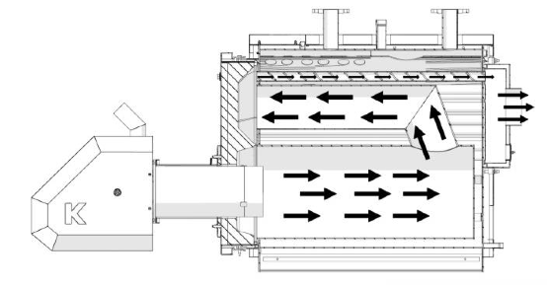

Additional Features

➢ Counter-Flow flue gas configuration - assures optimum heat transfer efficiencies

➢ Automatic wood pellets ignition system - eliminates operational maintenance

➢ Minimum 3” High Temperature insulation - reduces boiler heat losses

➢ Low electrical energy consumption – additional cost savings
